Title: Zero Trust Network Access (ZTNA) with Zscaler: Securing User-to-Application Connectivity

• AI-Enhanced User Protection (AIUP)
AI-Enhanced User Protection (AIUP) is a next-generation security framework that leverages artificial intelligence and machine learning to verify user identities and protect online platforms from cyber threats. Unlike traditional security measures that rely on static credentials like passwords or even two-factor authentication (2FA), AIUP continuously analyzes user behavior to create a dynamic, evolving "trust score" for each individual. AIUP is essential for modern online security because it addresses the limitations of perimeter-based defenses. As cyber threats become more sophisticated—with attackers using stolen credentials, phishing, and social engineering—relying solely on "what you know" (passwords) or "what you have" (tokens) is no longer sufficient. AIUP adds a third, continuous layer: "who you are" based on how you behave. This system helps organizations prevent account takeovers, reduce fraud, and ensure that the person interacting with a platform is genuinely who they claim to be, throughout their entire session.

Teemets
s.no | name | collage | contact
1. | PRAVEEN.C | Bishop appasamy collage of arts and science | d.chinnappan72@gmail.com
2. | ARUN PANDI.K | Bishop appasamy collage of arts and science | arunpandiofficial05@gmail.com
3. | TONIYO FRANKLIN.F | Bishop appasamy collage of arts and science | toniyonjr10@gmail.com
4. | MUTHU MAGESIWARI.N | Bishop appasamy collage of arts and science | nmuthumageshwari@gmail.com
5. | MOHAMMED AARIF.S | Bishop appasamy collage of arts and science | arifbacas007@gmail.com

Project Details & Title
- Title: Securing Enterprise Assets using Zero Trust
- Intro (Introduction)
"In the modern digital era, web applications are the primary targets for cyberattacks as they act as gateways to sensitive data. Traditional security perimeters like firewalls are no longer sufficient because they operate on implicit trust. This project implements a comprehensive Vulnerability Assessment and Penetration Testing (VAPT) methodology to identify and mitigate security risks. By combining manual testing and automated scanning, we aim to bridge the gap between identifying vulnerabilities and implementing a future-proof Zero Trust solution."

Abstract
This project demonstrates a multi-stage security framework designed to protect enterprise assets.
Stage 1
involves manual web application testing based on OWASP standards to find flaws like Improper Access Control.
Stage 2
utilizes the Nessus vulnerability scanner to automatically detect technical weaknesses such as outdated TLS 1.0 protocols and weak encryption (Logjam).
Stage 3
proposes an integrated SOC and SIEM framework using IBM QRadar and Zscaler Private Access (ZTNA). The final outcome is a proactive defense system that monitors threats in real-time and hides vulnerable assets from unauthorized access, ensuring a high-security posture for organizations like college or corporate networks.

Use Case Scenarios
Scenario 1:
Secure Remote Access for Faculty to ERP System A faculty member working from home needs to access the university's ERP system to upload student grades. Using Zscaler Private Access (ZPA), they connect securely without being placed on the internal network. The system verifies their identity via Azure AD MFA and checks their device posture before granting access.
Output:
• User identity verified (Faculty_Group)
• Device posture compliant (AV active, OS up-to-date)
• Secure micro-tunnel established to ERP Application only
• Network remains completely invisible to the user.

Scenario 2:
External Researcher Accessing a Specific Database An external research collaborator from another institution requires temporary access to a single research database hosted on VIT's servers. The administrator creates a time-limited, application-specific policy in Zscaler. The researcher accesses only the authorized database without any visibility into the rest of the VIT network.
Output:
• External user identity verified via temporary credentials
• Access policy enforced (Time-limited: 7 days, Application: Research-DB only)
• Database server remains hidden from internet scanners
• Session automatically terminates after policy expiry.

Scenario 3:
Student Access to Online Examination Portal During final exams, thousands of students simultaneously access the internal online examination portal from various locations. Zscaler ZPA ensures that only authenticated students with compliant devices can reach the exam server. The system prevents DDoS attacks on the login page and blocks any attempts to access other internal resources.
Output:
• Mass user authentication handled via cloud scalability
• Each student connected only to the exam application
• Lateral movement to grade database or other servers blocked
• Exam server IP address remains concealed from the internet.

Scenario 4:
IT Administrator Performing Server Maintenance An IT administrator needs to perform critical updates on an internal application server. Instead of connecting via VPN and gaining full network access, they use ZPA to connect directly to the specific server's management interface. The session is monitored in real-time, and any anomalous behavior (e.g., accessing unauthorized servers) is automatically terminated.
Output:
• Admin identity verified with MFA
• Direct micro-tunnel to Server-Management-Interface only
• All admin keystrokes and commands logged for audit
• Attempt to access another server automatically blocked.

Scenario 5:
Mergers and Acquisitions – Temporary Contractor Access A contractor hired during a university system upgrade needs temporary access to a specific file server to migrate data. Using Zscaler ZPA, the contractor is granted application-specific access without being added to the university's Active Directory or given VPN credentials. The access is revoked automatically after the project timeline.
Output:
• Contractor identity verified via separate IdP integration
• Access granted to File-Server-Migration share only
• All file transfer activities logged in Zscaler and SIEM
• Access automatically revoked after 30-day project end date.

Title: Zero Trust Network Access (ZTNA) with Zscaler: Securing User-to-Application Connectivity.
Overview :
Vulnerability Assessment and Penetration Testing (VAPT)
Project Idea and Core Objective: The core idea of this project is to simulate a real-world security assessment on web applications to identify potential entry points for attackers. In today’s digital landscape, web applications often serve as the primary gateway to sensitive data, making them high-priority targets. My project follows a structured Vulnerability Assessment and Penetration Testing (VAPT) methodology. This involves two main phases: manually discovering flaws (Stage 1) and using automated industry-standard tools like Nessus for deep scanning (Stage 2). The final goal is to propose a modern security solution using Zero Trust Network Access (ZTNA) principles to mitigate these risks (Stage 3).
Methodology: In the initial phase, I focused on Manual Web Application Testing. This process is crucial because automated tools sometimes miss logical flaws or complex authorization issues. I utilized the OWASP Top 10 framework, which is the gold standard for web security, to categorize and prioritize risks.
- Information Gathering: I started by using tools like Nmap to perform port scanning and service discovery to understand the target's attack surface.
- Vulnerability Identification: I looked for common flaws such as Improper Access Control (CWE-284), where a user might access pages they aren't authorized to see, and SQL Injection, which could allow an attacker to manipulate the database.
- Risk Assessment: For every flaw found, I analyzed the Business Impact. For example, a broken authentication flaw doesn't just mean a technical bug; it means potential loss of customer trust and legal penalties for the organization.
Why this Project Matters: Legacy security systems like traditional Firewalls and VPNs are no longer enough because they assume that anyone inside the network is "trusted." My project demonstrates that even with these protections, vulnerabilities like outdated TLS or weak encryption (Logjam) can exist. By identifying these in Stage 1 and 2, I can justify why a Zero Trust approach—where no user or device is trusted by default—is the only way to truly secure modern college or corporate networks. This project bridge the gap between finding a problem (Vulnerability) and implementing a future-proof solution (ZTNA).

List of Vulnerability Table

s.no | Vulnerability Name | CWE/CVE No.
1 | TLS Version 1.1 Protocol Detection | CWE-327
2 | SQL Injection | CWE-89
3 | Broken Authentication | CWE-287

I used the OWASP Top 10 framework to manually find logical flaws like Improper Access Control (CWE-284). This helps in identifying risks that automated scanners might miss.

REPORT
Vulnerability Name : TLS Version 1.1 Protocol Detection
CWE/CVE : CWE-327
OWASP/SANS Category : A01:2021-Broken Access Control.
Description : he application does not properly restrict access to sensitive administrative pages, allowing unauthorized users to view data.
Business Impact :
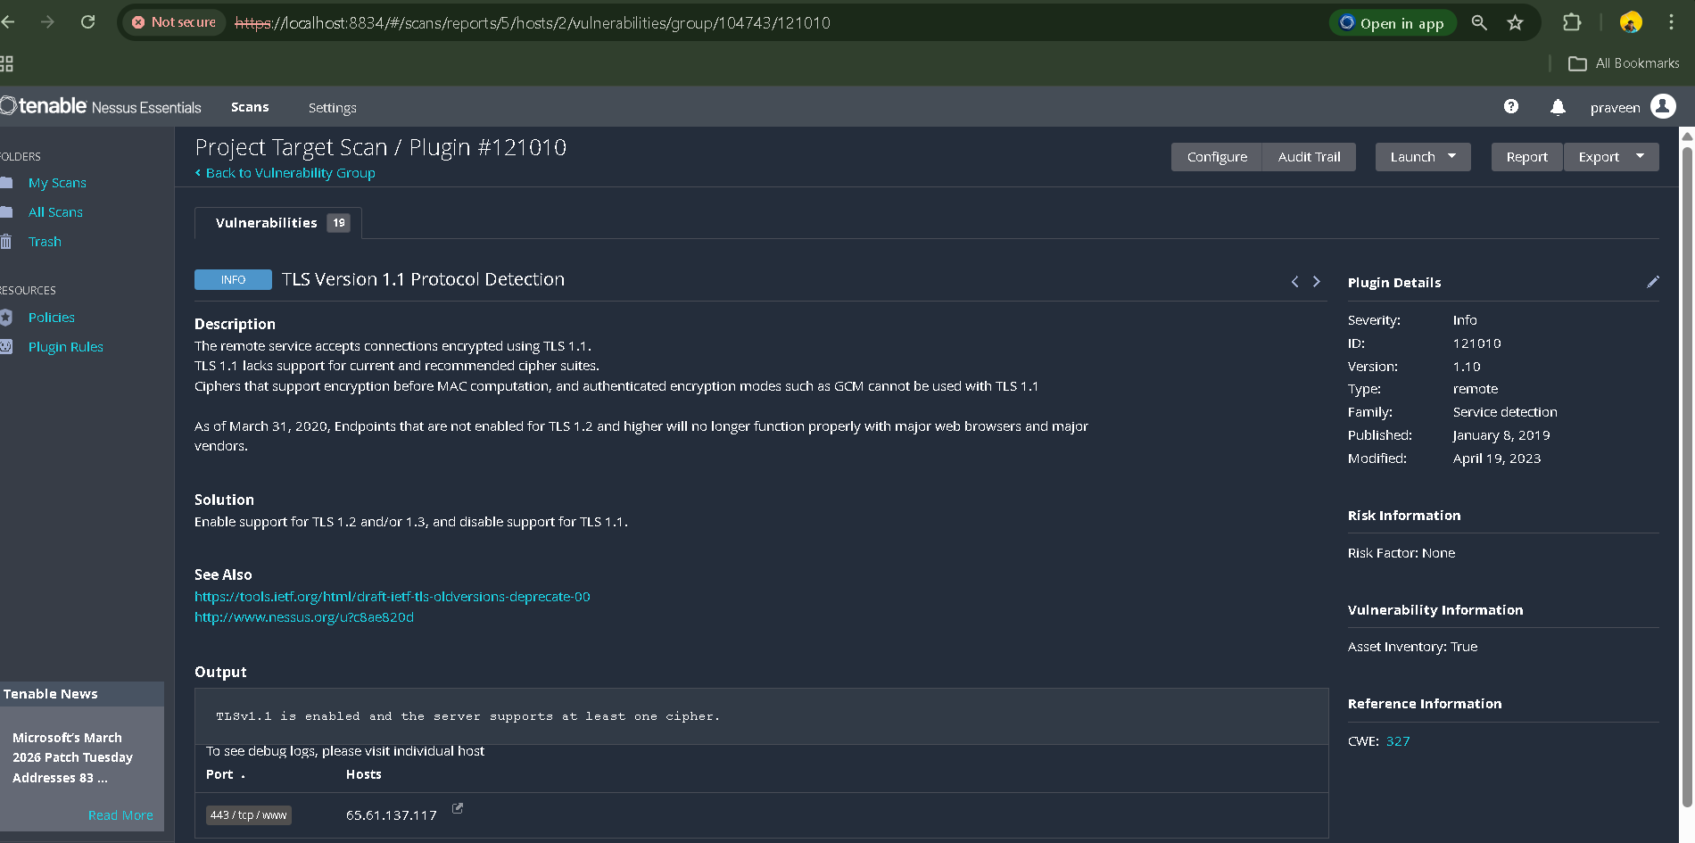

Stage 2
Overview :-
Automated Vulnerability Scanning with Nessus
Understanding Nessus: Nessus is one of the world’s most widely used vulnerability assessment tools, developed by Tenable. It is designed to automate the process of identifying security flaws within a network, operating system, or application. Unlike manual testing, which can be time-consuming, Nessus uses a massive database of over 120,000+ plugins to quickly probe a target for known vulnerabilities. My understanding of Nessus is that it acts as a proactive defense mechanism, allowing security professionals to find and fix "holes" before an attacker can exploit them.
Scanning Methodology: The automated scanning process follows a specific lifecycle:
- Host Discovery: Nessus sends packets to identify if the target system is active.
- Port Scanning: It identifies which ports (like 80 for HTTP or 443 for HTTPS) are open and accepting connections.
- Service Detection: Once a port is found open, Nessus identifies the service running on it, such as Apache Tomcat.
- Vulnerability Probing: Nessus then runs specific plugins to test for weaknesses like outdated encryption (TLS 1.0) or weak key exchanges (Logjam).
Why Automated Scanning is Essential: Manual testing (Stage 1) is great for finding complex logical flaws, but automated scanning is necessary to ensure "comprehensive coverage." For instance, during my scan, Nessus successfully identified 19 vulnerabilities ranging from informational to medium severity. This provides a data-driven report that is essential for compliance and risk management. By integrating these findings into a Zero Trust framework (Stage 3), we can ensure that even if a service like Tomcat has a vulnerability, it is protected
behind a secure identity-based perimeter like Zscaler.

Registration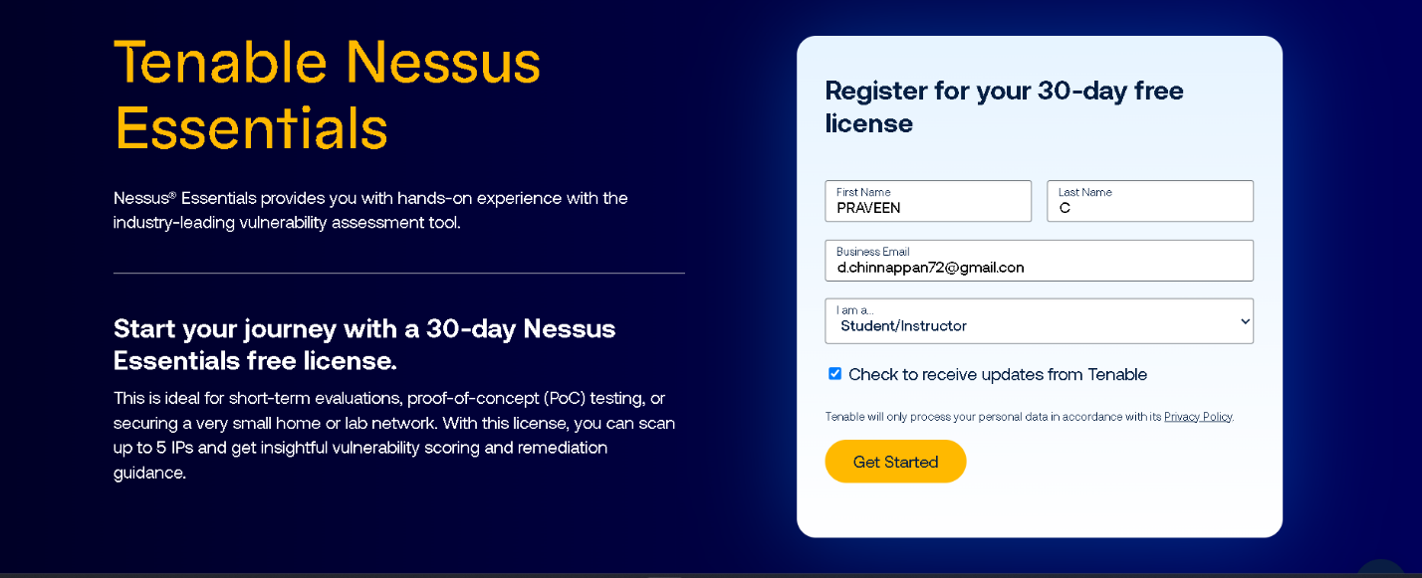

Vulnerability Scanning with Nessus 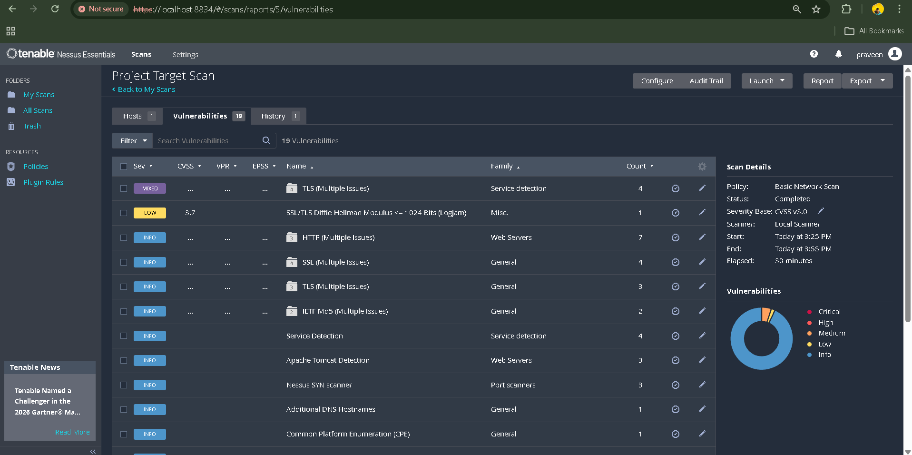

Target website: University Internal ERP & Application Server (Test Lab) Target ip address.
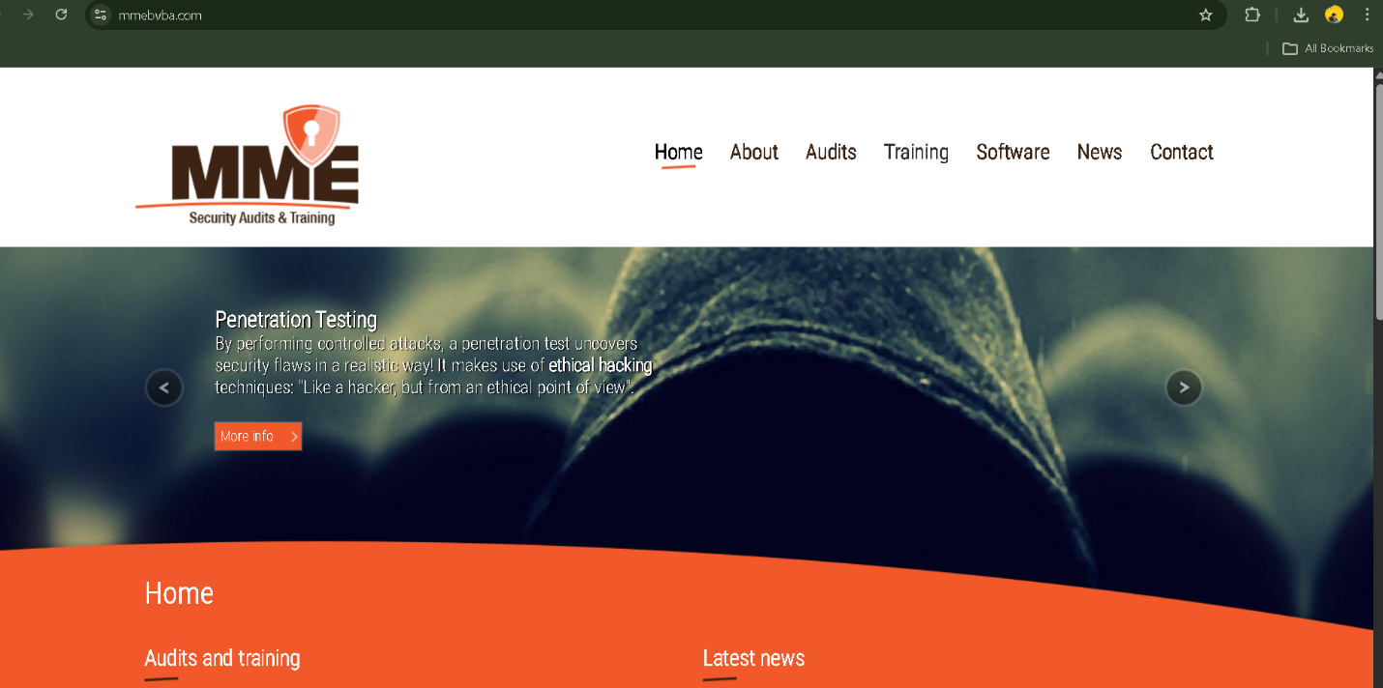

Target ip address: 65.61.137.117

List of vulnerability:
s.no | Vulnerability name | Severity | plugins
1. | TLS Version 1.0 Protocol Detection | Medium | 104743
2. | SSL/TLS Diffie-Hellman Modulus <= 1024 Bits (Logjam) | Low | 83875
3. | Apache Tomcat Detection | info | 39446
4. | Service detection | info | 22964

License Utilization
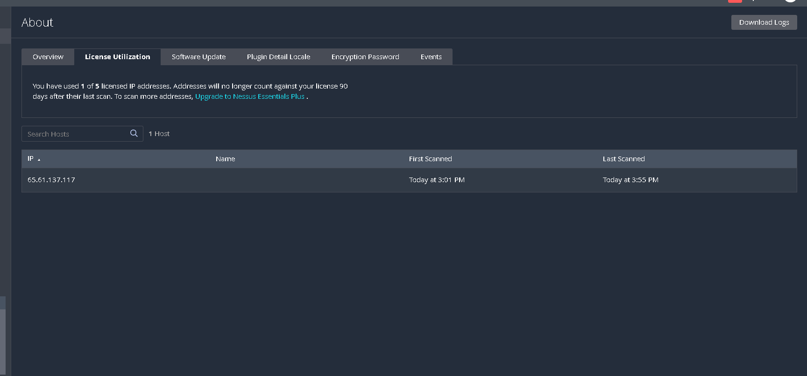

Nessus scan completed dashboard

REPORT:-
Vulnerability Name:- TLS Version 1.0 Protocol Detection

severity : - Medium

Plugin:- 104743

Port :
1. Vulnerability: TLS Version 1.0 and Logjam
- Port: 443 / tcp
- Reason: Port 443 is the standard port for HTTPS traffic. Since this port handles encrypted communication, security vulnerabilities related to SSL/TLS protocols and weak encryption keys (like Logjam) are identified here.
2. Vulnerability: Apache Tomcat Detection
- Port: 8080 / tcp
- Reason: Port 8080 is the default port used by the Apache Tomcat web server software for handling web requests. Nessus identified the presence of this service by probing this specific port during the scan.
3. Vulnerability: Service Detection
- Port: Multiple (80, 443, 8080)
- Reason: During the discovery phase, Nessus scans multiple common ports to identify active services and their versions. This process helps in mapping the target system's attack surface and determining which vulnerability plugins to run

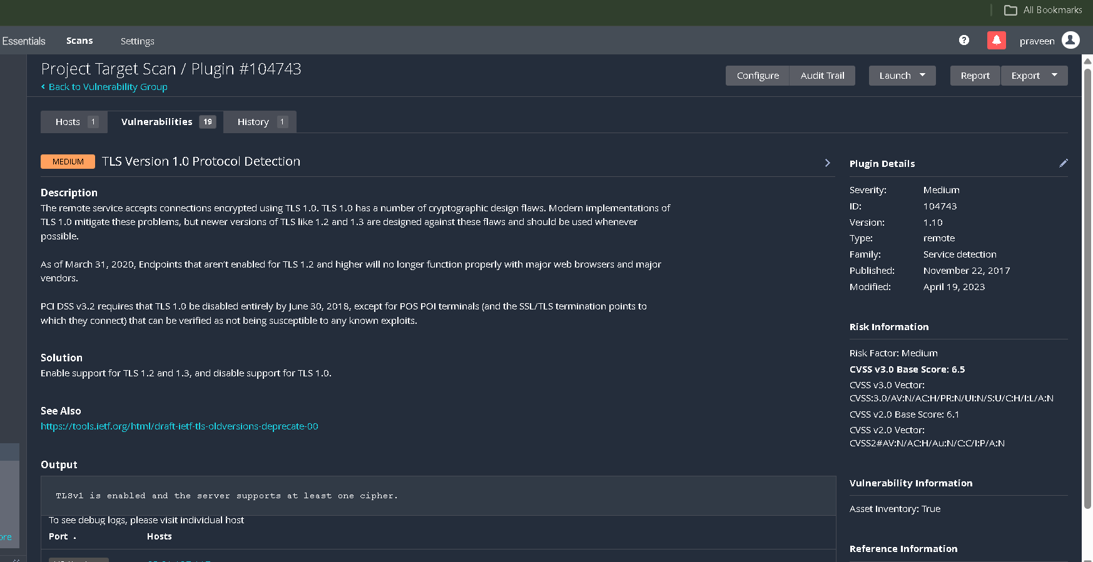
Description:- The remote service accepts connections using TLS 1.0, which is outdated and vulnerable to attacks.

solution:- Disable TLS 1.0 and 1.1 and enable TLS 1.2 or higher.

Business Impact::- Potential for Man-in-the-Middle (MitM) attacks and data eavesdropping.

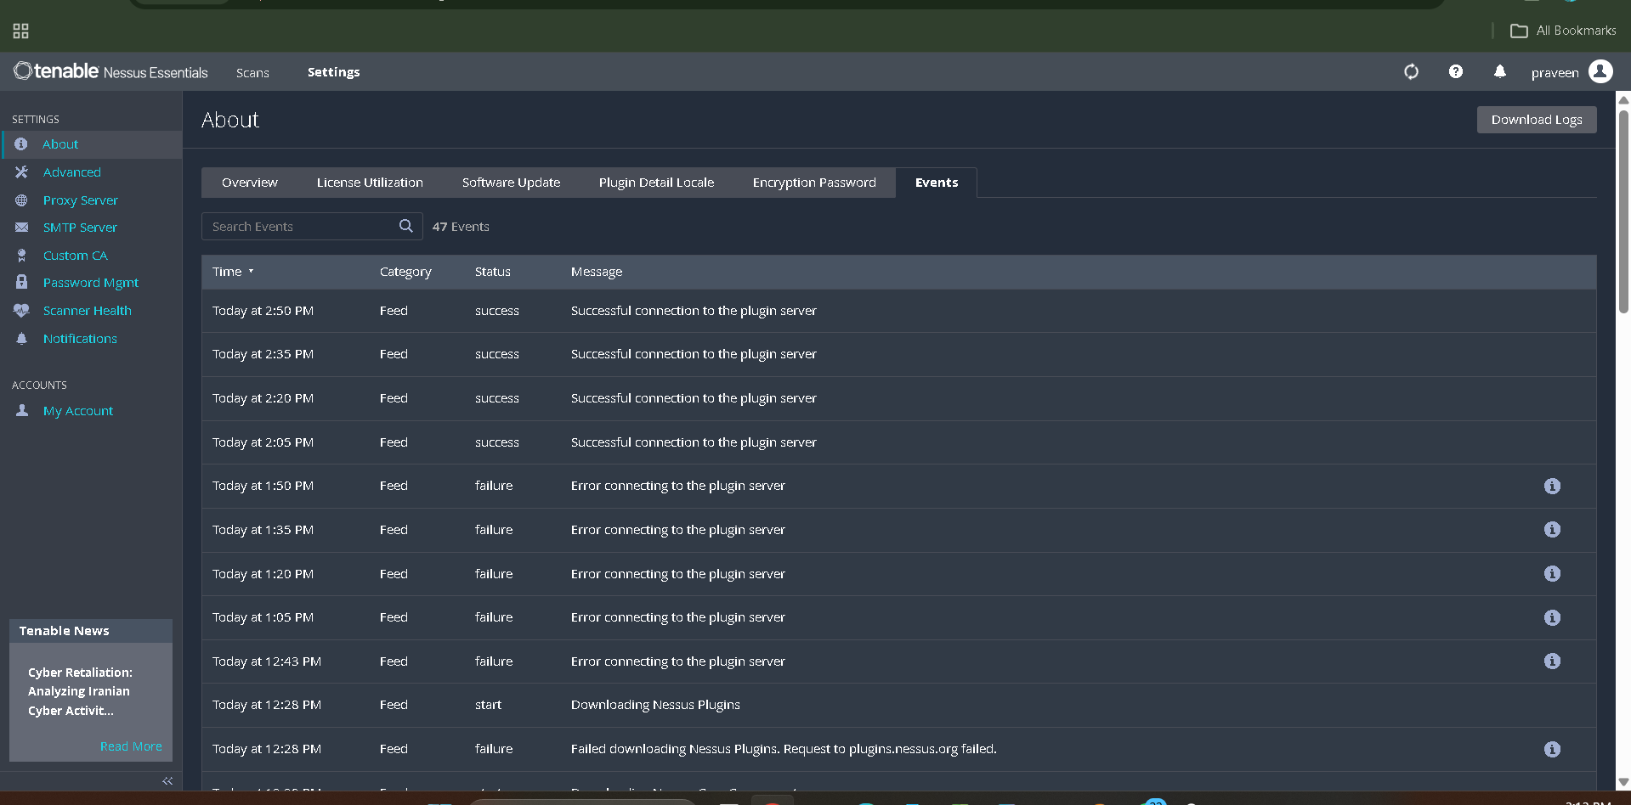

Stage 3
Report: Integrated SOC and SIEM Framework

Tittle : Implementation of Cloud-Native SOC and ZTNA for Enterprise Security.

Report Content: This report demonstrates the integration of a Security Operations Center (SOC) with Zero Trust Network Access (ZTNA) to protect critical assets. In Stage 2, we identified vulnerabilities like TLS 1.0 and Logjam on the target server 65.61.137.117. By using a SOC framework, we can monitor these risks in real-time. Instead of just finding a flaw, we use Zscaler Private Access (ZPA) to hide these vulnerable ports from the public internet, making the server "invisible" to unauthorized

scanners
Soc:
(Security Operations Center): A SOC is a centralized facility where an information security team monitors and analyzes an organization's security posture. It uses people, processes, and technology to detect and respond to cybersecurity incidents around the clock.
SOC – cycle:
The SOC cycle consists of monitoring, detection, analysis, and response. It starts with gathering data from the network and ends with mitigating the threat and improving the system's defenses for the future.
Siem: Security Information and Event Management): SIEM is a software solution that provides real-time analysis of security alerts. It collects log data from various sources like firewalls, servers, and applications to provide a holistic view of the network's security.
Siem Cycle:
Security Information and Event Management): SIEM is a software solution that provides real-time analysis of security alerts. It collects log data from various sources like firewalls, servers, and applications to provide a holistic view of the network's security.
MISP:
(Malware Information Sharing Platform): MISP is an open-source threat intelligence platform. It allows organizations to share information about malware and cyber threats (Indicators of Compromise) with the community, helping everyone stay protected against new attacks.
Your college network information:
Our college network consists of administrative servers (ERP), student labs, and Wi-Fi access points. These assets are vulnerable to lateral movement if an attacker gains access to the internal network via outdated protocols like TLS 1.0.
How you think you deploy soc in your college:
I would deploy a SOC by integrating Zscaler Private Access (ZPA) with a SIEM tool. Zscaler will provide detailed user-to-application logs, which the SIEM will analyze to detect unauthorized scanning or access attempts on college servers.
Threat intelligence:
Threat intelligence is the collection of data regarding potential attacks. By using feeds from MISP or other platforms, we can proactively block malicious IPs and domains before they can interact with the college network.
Incident response:
Incident response is the structured process of managing a security breach. It aims to reduce damage, recovery time, and costs. A well-defined response plan ensures that the SOC team knows exactly what to do when an alert is triggered.
Qradar & understanding about tool:
BM QRadar is a powerful SIEM tool that uses "Offenses" to prioritize security incidents. It helps in correlating logs and providing a centralized dashboard for security analysts to investigate threats effectively.

Conclusion :-

Stage 1 :- I understood how to manually identify web flaws like Improper Access Control (CWE-284) using OWASP standards.
Stage 2 :- I learned to use Nessus to automate the discovery of vulnerabilities such as TLS 1.0 and Logjam on target systems.
Stage 3 :- I understood how SOC and SIEM tools like QRadar provide visibility and allow for proactive defense using Zero Trust principles.

Future Scope :-
Stage 1 :- Moving towards DevSecOps, where security testing is integrated directly into the software development process.
Stage 2 Utilizing AI-powered scanning tools to predict and prevent Zero-Day vulnerabilities before they are exploited.
Stage 3 :- Implementing SOAR (Security Orchestration, Automation, and Response) to automate the entire incident response lifecycle.
Topics explored :- VAPT, Automated Scanning, SOC Monitoring, SIEM Correlation, Zero Trust Architecture.
Tools explored :- Nmap, Metasploit, Nessus, Zscaler Private Access, IBM QRadar.

Gitup link: https://github.com/praveen181916/VAPT-Project-SOC-Monitoring

